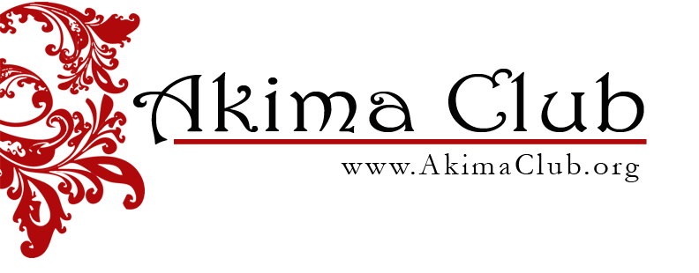

Thank you for your interest in applying for a grant. Our grant application will be available for download on December 1, 2024, so please visit us again then.

Thank you,

Grant Assistance Committee, 2024-2025

